Day 1 – Day 2
TAILEVU/NAMOSI WARD ROOF TOP – CONCRETE TANKS: 3,000 LITRES – “BEFORE WORK COMMENCEMENT”
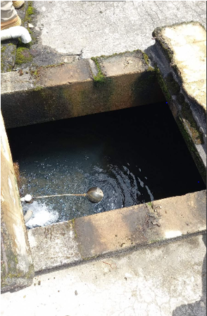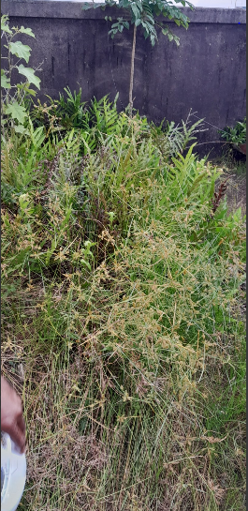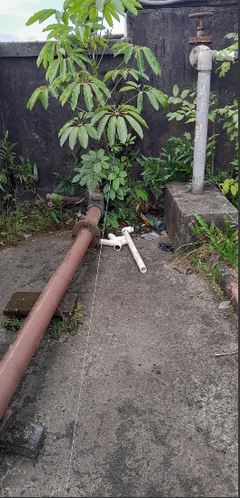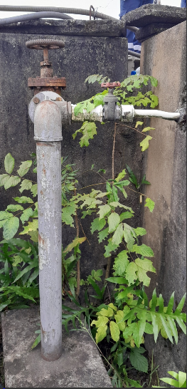
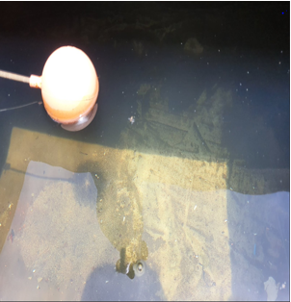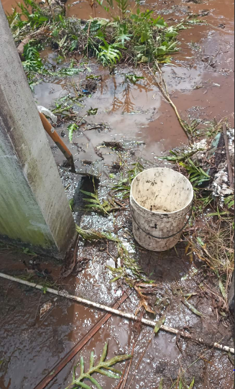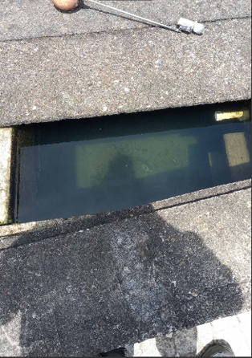
Please Click On the Link to View the Videos Of Before Vacuuming Out Of Dirt from 3,000 Litres of Tailevu/Namosi Concrete Tanks
- https://drive.google.com/file/d/1pft446sy6ZMEZXna6-GDUeQP5cSC994u/view?usp=sharing

- https://drive.google.com/file/d/1TcGI1YZ-p_ZEjOd1KSdMw2R1gxLrz5Ou/view?usp=sharing

- https://drive.google.com/file/d/1V8HHCTdzlaQXxJUuf8uSW1OQaEZGb5N_/view?usp=sharing

- https://drive.google.com/file/d/1rgxpJgUrX6lERdGhF17vwoF8UCuGkiQq/view?usp=sharing
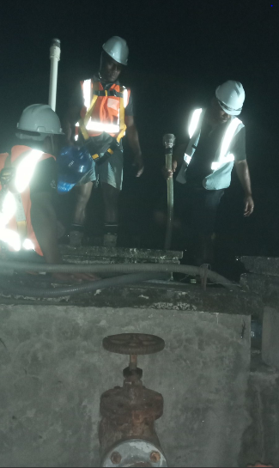
TAILEVU/NAMOSI WARD ROOF TOP – CONCRETE TANKS: 3,000 LITRES – “DURING WORK COMMENCEMENT”
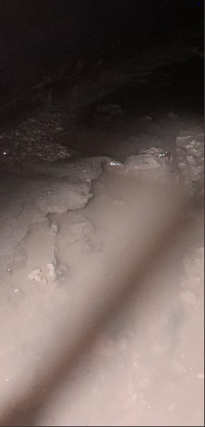
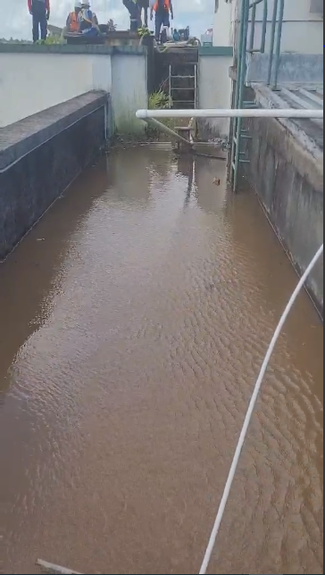
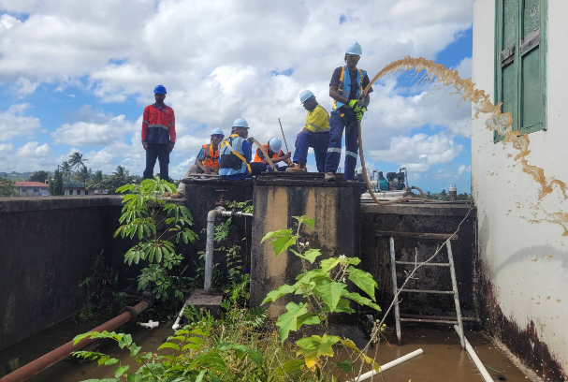
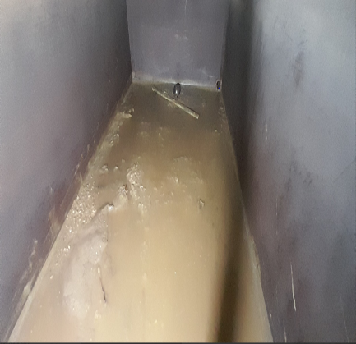
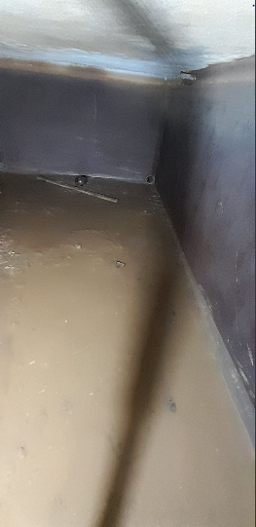
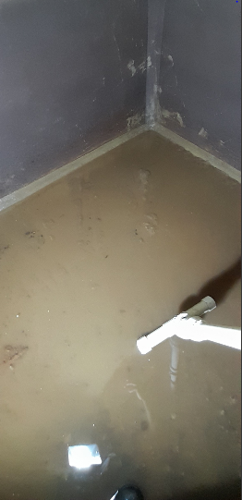

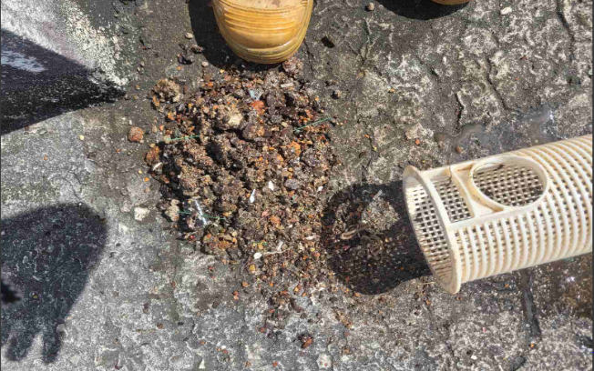
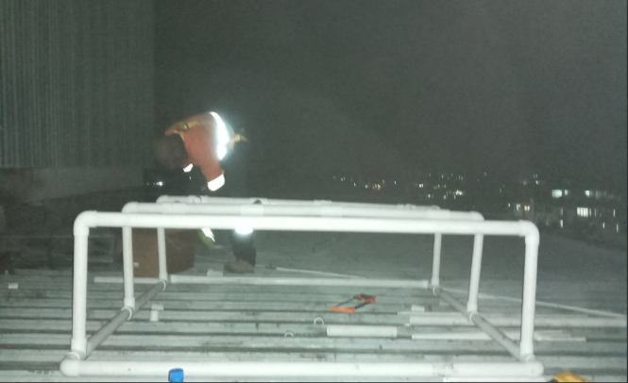
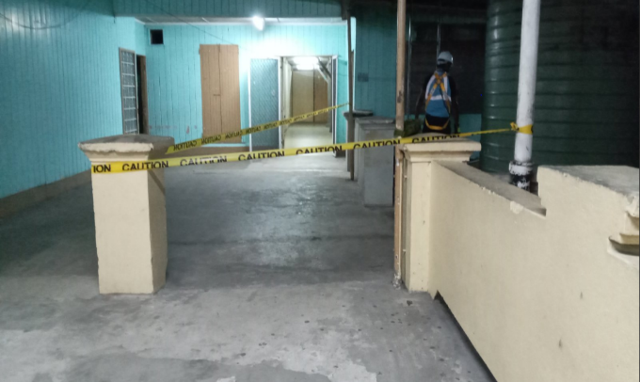

Please Click On the Link to View the Videos Of During Vacuuming Out Of Dirt from 3,000 Litres of Tailevu/Namosi Concrete Tanks
- https://drive.google.com/file/d/1-m8YqFhUxWEwpjmadneGjgrMtJpThxZf/view?usp=sharing

- https://drive.google.com/file/d/15fuhe_nnPRsS2gDVB4omzd9G8BN3VAdp/view?usp=sharing

- https://drive.google.com/file/d/1-ynqpz_vJ9gM64SaXpwPKdkJSszHMphJ/view?usp=sharing

- https://drive.google.com/file/d/1-dIgHhoi9LHWVuwx091OIXV4UxgUOhbj/view?usp=sharing

- https://drive.google.com/file/d/10Gu0CD2JsLesMmjWismImPEi3DBmseP6/view?usp=sharing

- https://drive.google.com/file/d/1-z26DbtQxVIpllSlO7Xx_M7F8wSB88J_/view?usp=sharing

- https://drive.google.com/file/d/106KkaS4q_ftUaynMTRTnvxBAACgEuhrU/view?usp=sharing

- https://drive.google.com/file/d/1qlHGBC7YiUEDHlh4V2wg9CQtoudncOXm/view?usp=sharing

- https://drive.google.com/file/d/1-ywiwpaOoK-YpF5y481VTi0icCMmiw74/view?usp=sharing

- https://drive.google.com/file/d/1024INKj7uDTGs-d5PkH5quGHboetNsHq/view?usp=sharing

- https://drive.google.com/file/d/1rgxpJgUrX6lERdGhF17vwoF8UCuGkiQq/view?usp=sharing

- https://drive.google.com/file/d/1-zsbQ_LULy2z3--tt8luLe-MV4_kNKZH/view?usp=sharing

- https://drive.google.com/file/d/1-sj5VuM7pIFbTdpI2RHVlaY1WABD2Nzd/view?usp=sharing

Below Is the Link for the Video of during Exterior cleaning
- https://drive.google.com/file/d/17H6GyT2Q724hbVAZl5SA6grF2wDls4r4/view?usp=sharing

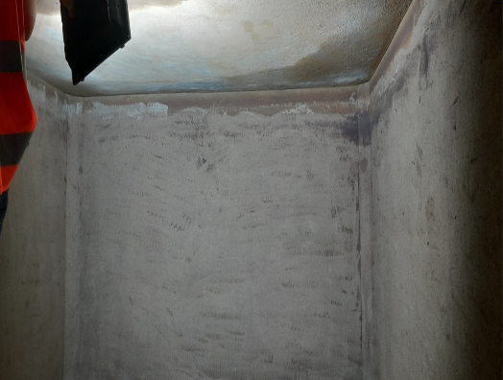
TAILEVU/NAMOSI WARD ROOF TOP – CONCRETE TANKS: 3000 LITRES – AFTER WORK IMAGES/VIDEOS
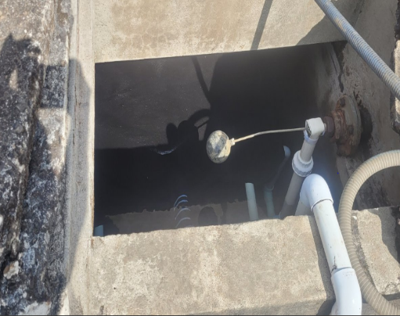
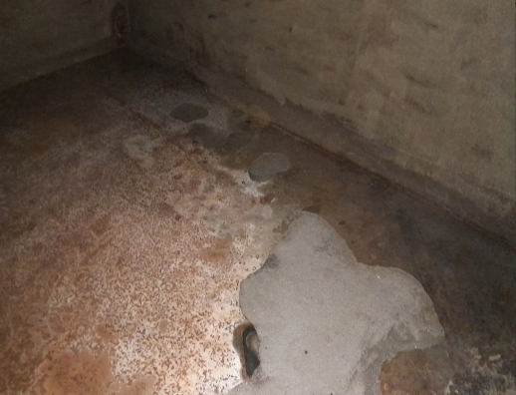
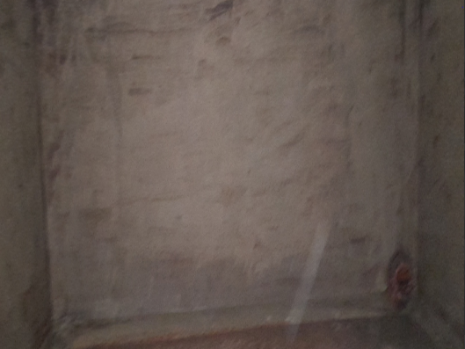

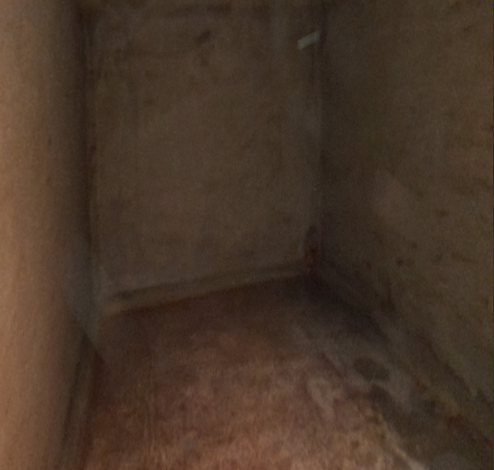
Below Is the Link for the Video of After Vacuum/Water Blasting

- https://drive.google.com/file/d/1x4jh1bHMThs_34C_edPDxYp18ES4E3d/view?usp=sharing

Please Click On the Link to View the Videos Of After Vacuuming Out Of Dirt

- https://drive.google.com/file/d/1x4jh1bHMTh-s_34C_edPDxYp18ES4E3d/view?usp=sharing

For the Cleaning/Vacuuming of the Tailevu/Namosi Ward Roof Top:
- The team have had to split into 2 shifts (Night and Day Shift) due to the magnitude of the work on hand and also there is less consumption and demand for water after 5pm.
- Day shift team were tasked to conduct exterior cleaning without the use of the water blasting machine and also to put together frames with the filtration bags fitted on.
- The night shift was then tasked to install the filtration frames with filtration bags on it, vacuum and water blasting the interior and exterior of Tailevu/Namosi Ward Roof Top.

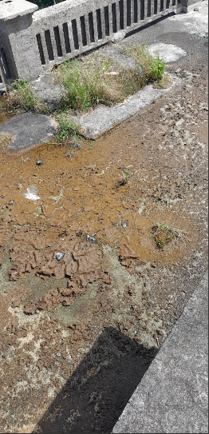
CWM HOSPITAL TOP KITCHEN – CONCRETE TANKS: 3,500 LITRES – “BEFORE WORK COMMENCEMENT”
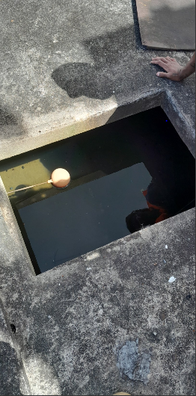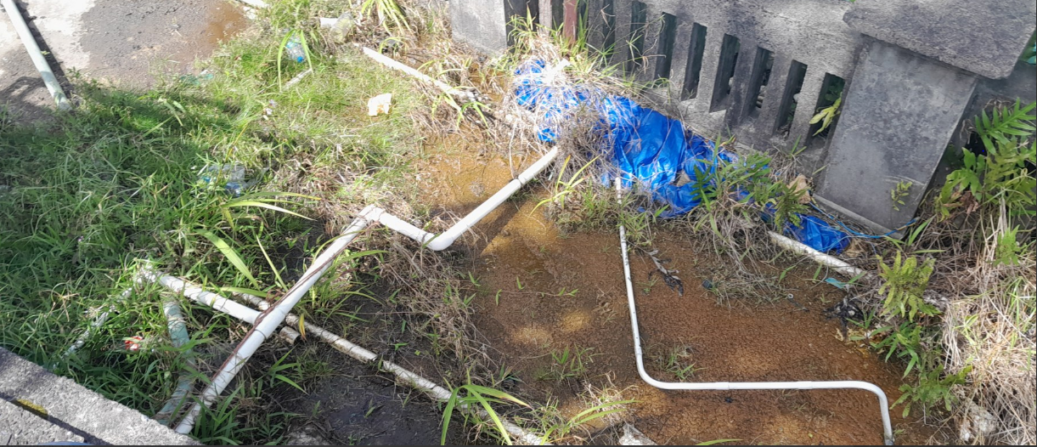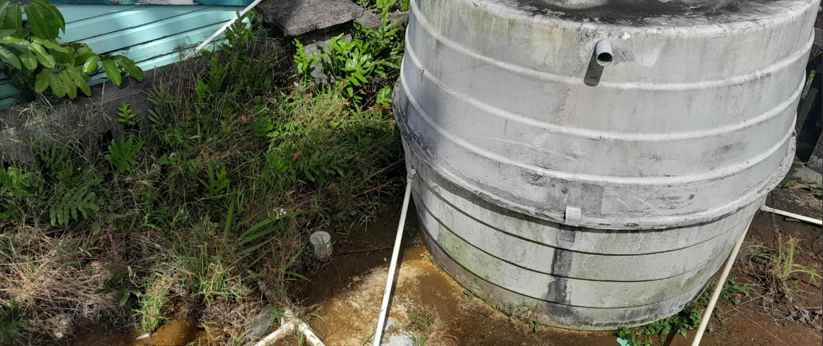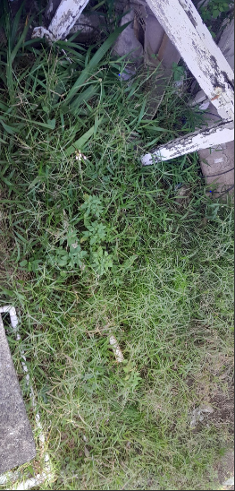
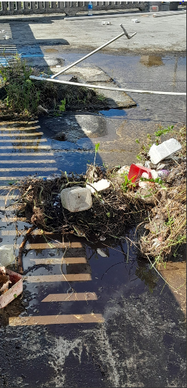
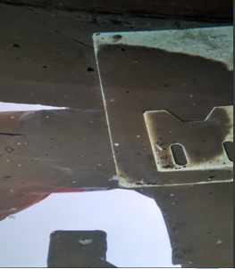
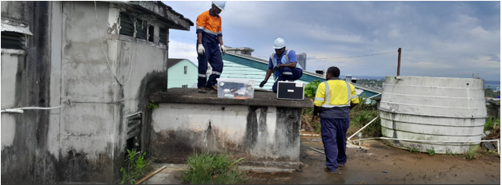
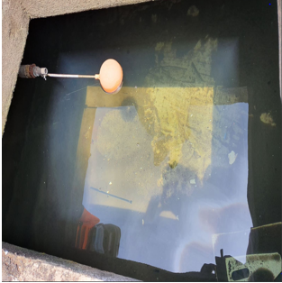
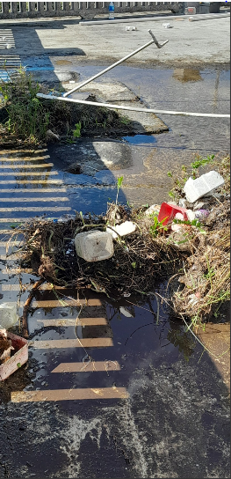

Please Click On the Link to View the Videos Of Before Vacuuming Out Of Dirt from 3,500 Litres of CWM Hospital Top Kitchen Concrete Tanks
- https://drive.google.com/file/d/1J6ugmyq2zrfv4WnVHfOyMCMNk2AEDLTO/view?usp=sharing

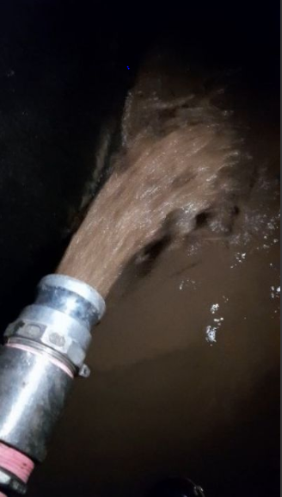
CWM HOSPITAL TOP KITCHEN – CONCRETE TANK: 3,500 LITRES – “DURING WORK”
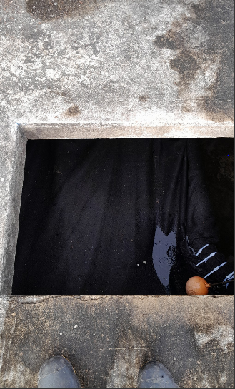
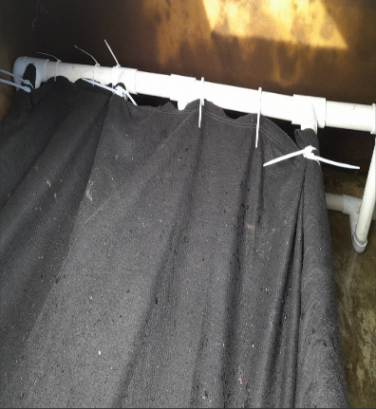
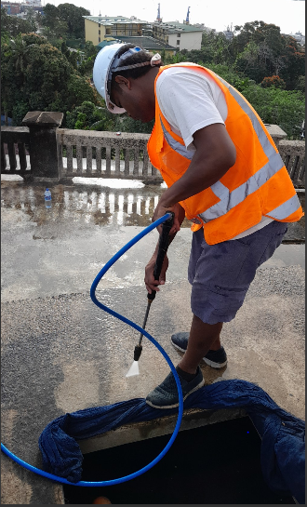
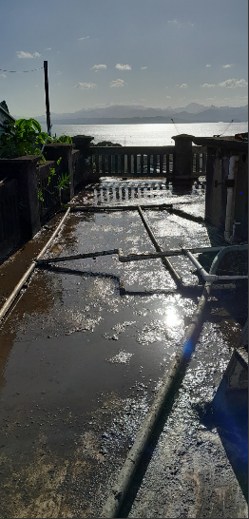
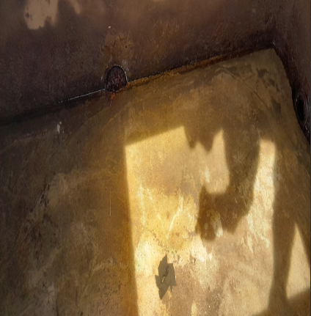
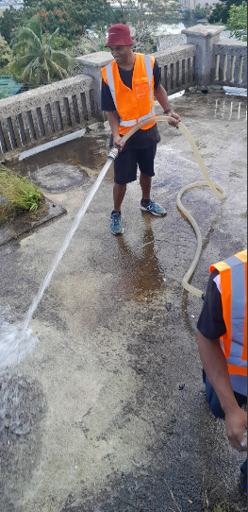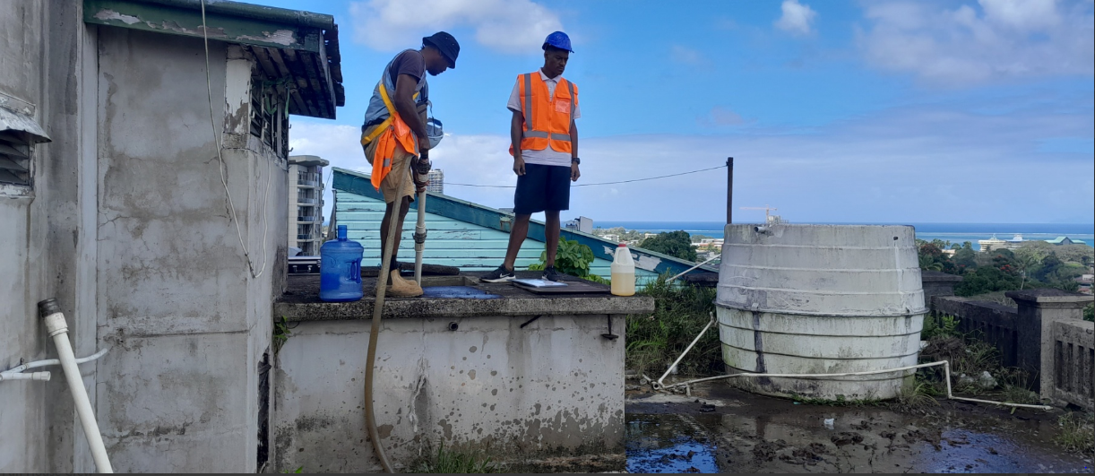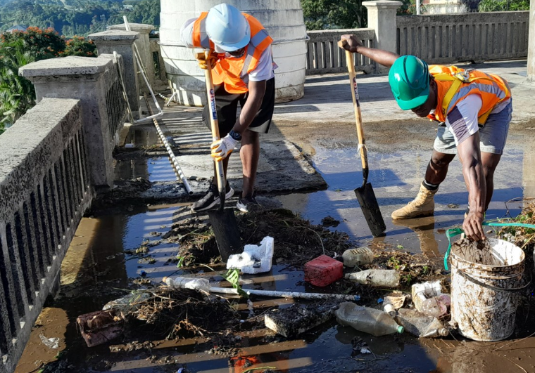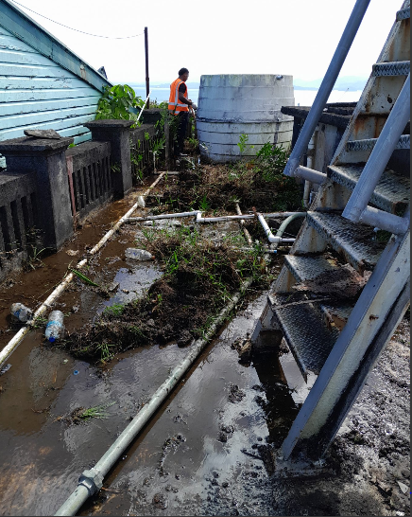

Please Click On the Link to View the Videos Of During Vacuuming Out Of Dirt from 3,500 Litres of CWM Hospital Top Kitchen Concrete Tank
- https://drive.google.com/file/d/10-uTq84EQr-gu2KAOTX2a4gvM1SHNLy1/view?usp=sharing

- https://drive.google.com/file/d/10J4k634p9CDpVE4FsTcxlsmJ4X1oQKwA/view?usp=sharing

- https://drive.google.com/file/d/1-vCkXjYY0LEaBZ-D6SKMMGbsgR8Ggdet/view?usp=sharing

- https://drive.google.com/file/d/101YPqWNqfdcaYk9ps-uKtW2Y6vwqysVO/view?usp=sharing
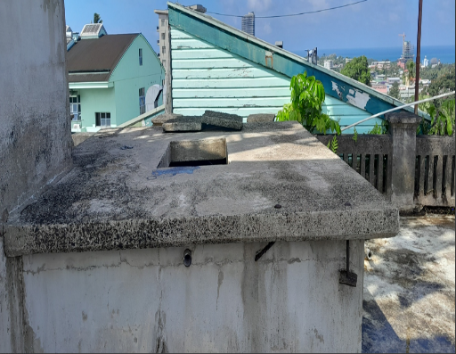
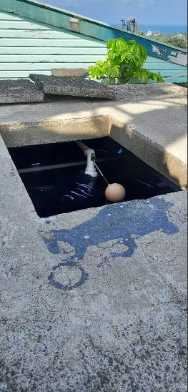
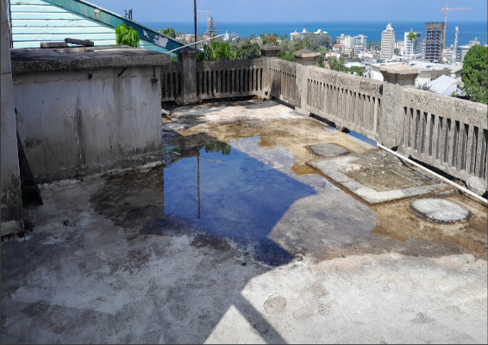
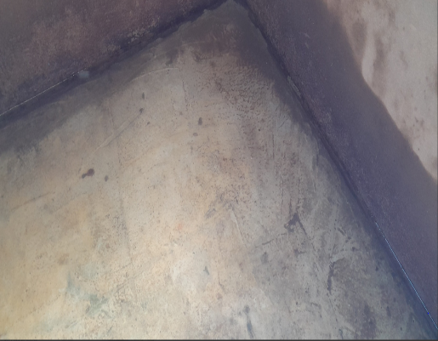
CWM HOSPITAL TOP KITCHEN – CONCRETE TANK: 3,500 LITRES – “AFTER WORK IMAGES”

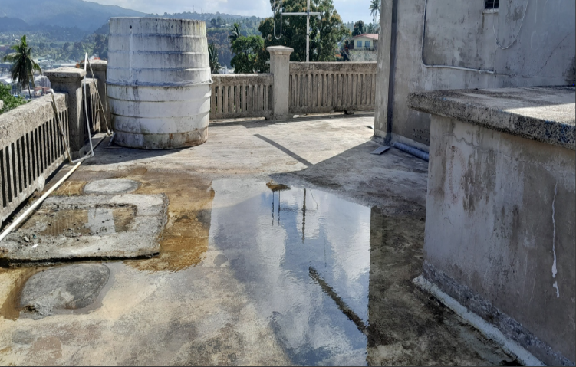
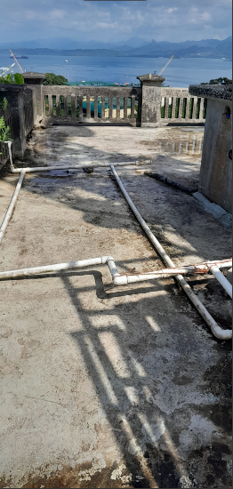
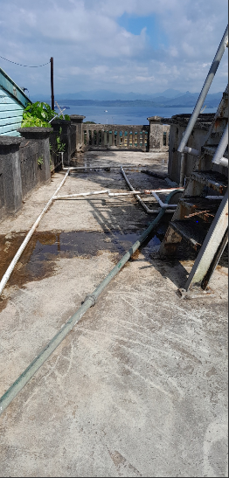

GENERAL REPORT ON THE CONCRETE TANKS LOCATED AT THE NAMOSI/TAILEVU WARD & AT CWM HOSPITAL TOP KITCHEN
- Multiple vacuum & multiple flushing out of dirt present on the concrete tanks. This eventually leads to the team emptying the whole concrete tank, removing all debris, sludge’s via water blasting. This is due to:
- Thickness of dirt and sludge that were present on the tank
- Multiple clogging of our filter due to the heaviness and thickness of sludge vacuumed out of the generator

- Disinfect & purify the water after it has been vacuumed and dirt flushed out using our new state of the art ozone generator
- Technicians had increase the time of ozone time due to the fact that the water tank was really dirty. This is to make it really safe for
all involve that is using water from this tank.

- Identify ways we can assist CWM Hospital in supplying clean and healthy water to all its users
- Technicians had identified ways to filter dirt before water enters the water tanks without the use of chemicals. This can be sent in a report form if requested

- Exterior cleaning and maintenance of water tanks and its surrounding areas. This involves:
- The cleaning of block drain
- Water blasting of the exterior layer of the concrete water tanks
- Removal of old soggy logs
- Removal of old roofing iron that was inside the concrete tank
- Water blasting which removed green mold on concrete base and the exterior of the concrete water tanks
- Water blasting which removed green algae on concrete moisture wall
RECOMMENDATION FOR THE CONCRETE WATER TANKS

- Concrete water tanks to be vacuumed and purified every 3 months.
- Exterior cleaning and maintenance to be done every month.
- Install filtration systems so that it captures dirt exiting out of the WAF supply pipes.

